ALMR – Hotel Carlina 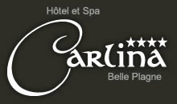

<http://www.carlina-belleplagne.com/?lg=2>

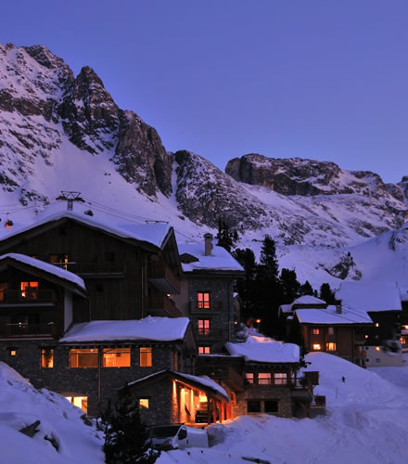

A warm and elegant hotel that will make you feel at home. Built in 2005, this year Le Carlina has added a spa with an indoor pool, new rooms, a children's area and a new restaurant.

The hotel's exceptional slope side location enables all levels of skiers to enjoy ski in, ski out comfort.

When you get back from your day out on the slopes, you can choose between relaxing in the spa or enjoying a drink in the bar with friends or family. Why not do both!

